COMPARATIVE TIME SERIES ANALYSIS AND FORECASTING OF STOCK RETURNS: A CASE STUDY OF MTN NIGERIA AND DANGOTE CEMENT (2020 – 2025)

BY
GROUP 2
Surname | Name
- Aladoye | Grace
- Adejumo | Tosin
- Jimoh | Teslim Abiodun
- Komolafe | Fatai Abiodun
- Olaniyan | Elizabeth

ABSTRACT
This research investigates the historical stock performance of MTN Nigeria and Dangote Cement using daily closing prices over a six-years period. The aim is to analyze, visualize, and forecast returns to assist investors and analysts in understanding market behavior. The methodology includes exploratory data analysis (EDA), return computation, outlier detection, stationarity testing, and ARIMA based time series forecasting. Results indicate volatility in returns with distinct patterns and trends across both stocks, offering useful insights for short-term forecasting and investment decisions.

1. INTRODUCTION
The Nigerian Stock Exchange (NGX) features prominent companies such as MTN Nigeria and Dangote Cement, which are critical players in the telecommunications and manufacturing sectors respectively. Monitoring and forecasting the stock market behavior of such companies can inform investment and policy decisions. This study explores historical price movements, evaluates statistical properties of stock returns, and applies time series models to forecast future values. The core motivation is to provide a simple yet powerful comparative analysis using only three essential columns: Date, MTN Close, and Dangote Close.

2. OBJECTIVES
To perform exploratory data analysis on stock prices of MTN Nigeria and Dangote Cement.
To compute and compare daily, weekly, and monthly returns for both stocks.
To detect outliers and check for distribution characteristics using statistical plots.
To evaluate stationarity using the Augmented Dickey Fuller (ADF) test.
To forecast future stock performance using time series models (ARIMA).
To draw insights into short term investment decision making.

3. DATA AND METHODOLOGY

3.1 Data Description
The dataset contains daily closing prices from 2020 to 2025 for both MTN Nigeria and Dangote Cement. The data has three columns: `Date`, `MTN_Close`, and `Dangote_Close`.

3.2 Data Preprocessing and Transformation
The data was transformed from wide to long format using `pivot longer()` to standardize the structure and simplify return calculation.

3.3 Return Calculation
Daily percentage returns were calculated using the formula:
Returnt​=(Pt−1​Pt​−Pt−1​​)×100
Where:
- PtP_tPt​ = Price of the stock at time t (today's closing price)
- Pt−1P_{t-1}Pt−1​ = Price of the stock at time t−1 (previous day's closing price)
- Returnt\text{Return}_tReturnt​ = Daily return at time t (in percentage)
This helps to measure relative changes in price and enables volatility analysis.
3.3.1 Daily Return Over Time Graph
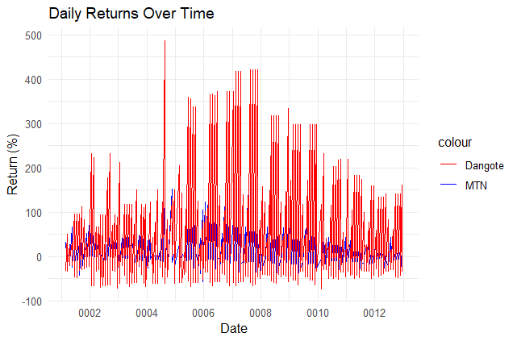
3.4 Exploratory Data Analysis (EDA)
Summary Statistics were used to understand the mean, median, standard deviation, and range of returns.
MTN_Return Dangote_Return
Min. :-58.5357 Min. :-72.932
1st Qu.: -3.4792 1st Qu.: -3.917
Median : 0.0000 Median : 0.000
Mean : 2.2491 Mean : 11.488
3rd Qu.: 0.4367 3rd Qu.: 0.000
Max. :152.6316 Max. :486.923
NA's :1 NA's :1
Boxplots identified outliers.
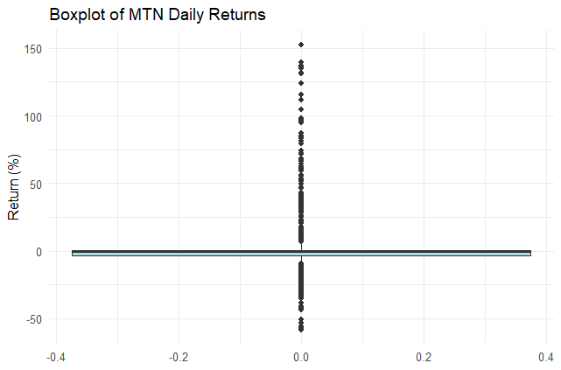 | 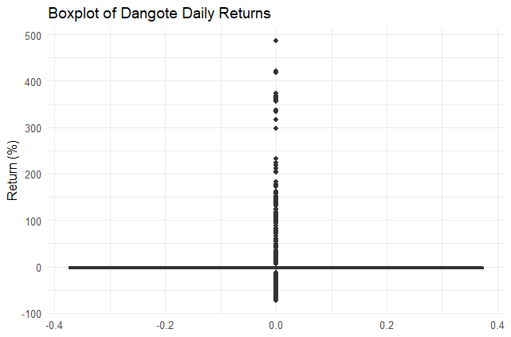

Histograms and
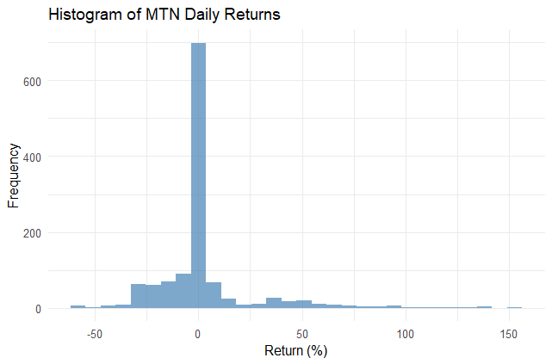 | 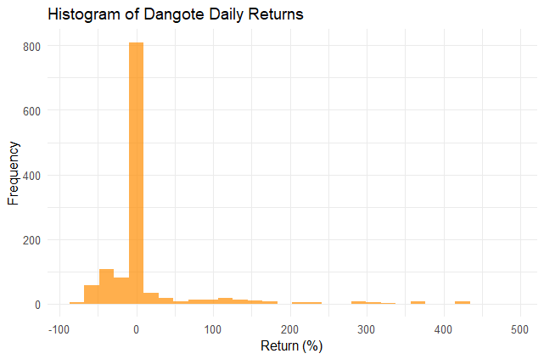

QQ plots checked the normality of return distributions.
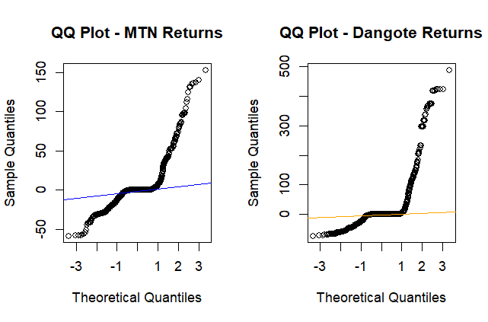
3.5 Stationarity Check
The ADF test was conducted to check for unit roots. Stationary series are necessary for reliable time series modeling.

3.6 Time Series Modeling and Forecasting
After transforming return series to time series objects using `ts()`, ARIMA models were fitted based on AIC selection. Forecasts were visualized with confidence intervals.

4. RESULTS AND DISCUSSION
MTN Nigeria showed slightly lower volatility compared to Dangote Cement.
Dangote Cement returns were more positively skewed.
Both series passed the stationarity test at 5% significance level after transformation.
The ARIMA model provided reasonable short-term forecasts with interpretable confidence intervals.
Outliers detected in the boxplot were mostly during market shocks (e.g., pandemic period).

5. CONCLUSION
This research demonstrated a practical application of time series analysis in finance, specifically stock returns forecasting. While the analysis was kept simple for beginner comprehension, the insights gained offer useful understanding into the risk return behavior of MTN and Dangote Cement.
Future research could incorporate volume, macroeconomic indicators, and sentiment analysis for improved predictive performance.

6. RECOMMENDATIONS
Beginner analysts can use return analysis and ARIMA modeling as a solid foundation before moving into more complex machine learning models.
Investors should consider both trend and volatility patterns before making investment decisions.
Companies should monitor their market performance trends for strategic positioning.

7. REFERENCES
(Include references to your data source, e.g., Investing.com, and any packages or textbooks used in your analysis)
Hyndman, R. J., & Athanasopoulos, G. (2018). Forecasting: principles and practice.
Investing.com (for stock data)
R Documentation for `forecast`, `tseries`, and `ggplot2` packages
8. APPENDIX
# === Load Libraries ===
library(tidyverse)
library(lubridate)
library(forecast)
library(tseries)
library(scales) # For better axis formatting

# === Load Dataset ===
data <- read_csv("C:/Users/USER/Downloads/Dangote_Mtn_Stock_6yrs.csv")
data$Date <- as.Date(data$Date)
data <- data %>% arrange(Date)

# Rename for easier reference
data <- data %>%
rename(
Dangote_Close = Dangote_cement,
MTN_Close = Mtn
)

# === Calculate Daily Returns ===
data <- data %>%
mutate(
MTN_Return = (MTN_Close - lag(MTN_Close)) / lag(MTN_Close) * 100,
Dangote_Return = (Dangote_Close - lag(Dangote_Close)) / lag(Dangote_Close) * 100
) %>%
filter(is.finite(MTN_Return), is.finite(Dangote_Return)) # Remove NA and Inf

# === Summary Statistics ===
summary_stats <- data %>%
select(MTN_Return, Dangote_Return) %>%
summary()
print(summary_stats)

# === Histograms ===
ggplot(data, aes(x = MTN_Return)) +
geom_histogram(bins = 30, fill = "steelblue", alpha = 0.7) +
labs(title = "Histogram of MTN Daily Returns", x = "Return (%)", y = "Frequency") +
theme_minimal()

ggplot(data, aes(x = Dangote_Return)) +
geom_histogram(bins = 30, fill = "darkorange", alpha = 0.7) +
labs(title = "Histogram of Dangote Daily Returns", x = "Return (%)", y = "Frequency") +
theme_minimal()

# === Boxplots ===
ggplot(data, aes(y = MTN_Return)) +
geom_boxplot(fill = "lightblue") +
labs(title = "Boxplot of MTN Daily Returns", y = "Return (%)") +
theme_minimal()

ggplot(data, aes(y = Dangote_Return)) +
geom_boxplot(fill = "orange") +
labs(title = "Boxplot of Dangote Daily Returns", y = "Return (%)") +
theme_minimal()

# === Line Plot of Daily Returns ===
ggplot(data, aes(x = Date)) +
geom_line(aes(y = MTN_Return, color = "MTN")) +
geom_line(aes(y = Dangote_Return, color = "Dangote")) +
labs(title = "Daily Returns Over Time", x = "Date", y = "Return (%)") +
scale_color_manual(values = c("MTN" = "blue", "Dangote" = "orange")) +
theme_minimal()

# === QQ Plots ===
par(mfrow = c(1, 2)) # Two plots side-by-side
qqnorm(data$MTN_Return, main = "QQ Plot - MTN Returns")
qqline(data$MTN_Return, col = "blue")

qqnorm(data$Dangote_Return, main = "QQ Plot - Dangote Returns")
qqline(data$Dangote_Return, col = "orange")
par(mfrow = c(1, 1)) # Reset layout

# === ADF Stationarity Test ===
cat("\nADF Test - MTN Returns:\n")
print(adf.test(data$MTN_Return))

cat("\nADF Test - Dangote Returns:\n")
print(adf.test(data$Dangote_Return))

# === ARIMA Forecasting ===
mtn_ts <- ts(data$MTN_Return, frequency = 252)
dangote_ts <- ts(data$Dangote_Return, frequency = 252)

# === MTN Forecast ===
mtn_model <- auto.arima(mtn_ts)
mtn_forecast <- forecast(mtn_model, h = 30)

autoplot(mtn_forecast) +
labs(title = "30-Day Forecast for MTN Returns", x = "Day", y = "Predicted Return (%)") +
theme_minimal()

# === Dangote Forecast ===
dangote_model <- auto.arima(dangote_ts)
dangote_forecast <- forecast(dangote_model, h = 30)

autoplot(dangote_forecast) +
labs(title = "30-Day Forecast for Dangote Returns", x = "Day", y = "Predicted Return (%)") +
theme_minimal()

